**Introduction to computer Science**

**Final Project**

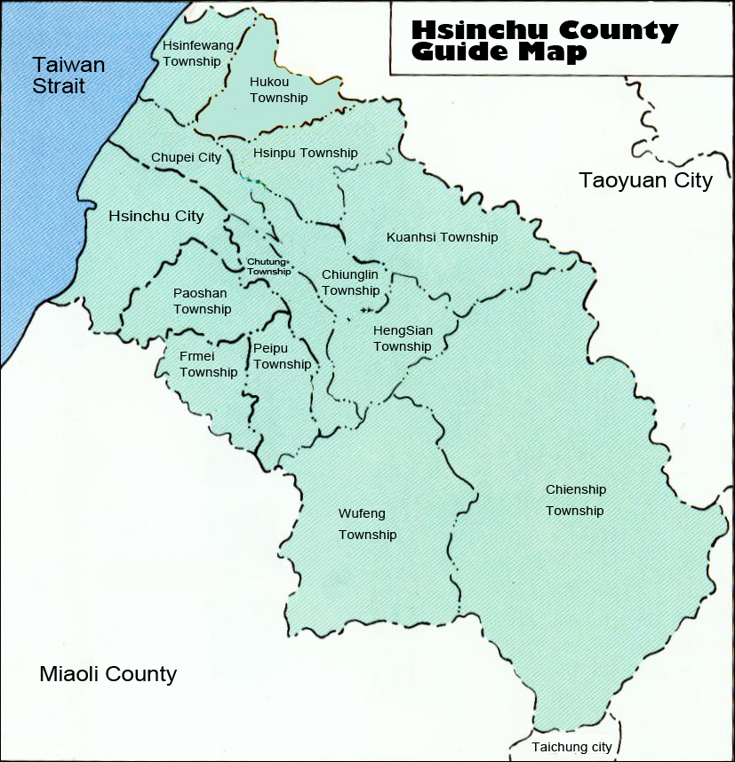

**Team 2**

**Member**

0316081 王威斌

0316083 陳逸群

0316094 甘敬軒

0316095 蔡健怡

0316098 李宗霖

0316218 董乃嘉

0316327 吳俊賢

0316339 陳霆峰

**To complete this final project , we divide our group into different team , including Team Query , Team Binary ,Team Database , Team API and Team GUI .**

**Team Binary**

**There are two members in this team. And the main purpose is to find maps and convert it to the coordinates, which we can use in the latter time, into a file.**

**The First Step**

**The very first step, we find a map in Google map. And we use Photoshop to sketch the Google Map to capture the boundaries between cities (figure 1), river basins (figure 2) and also the famous tourist attractions (figure 3). And export it to a PSD file.**

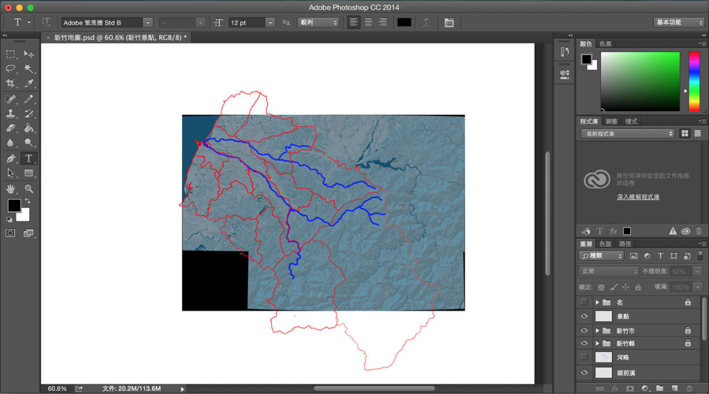

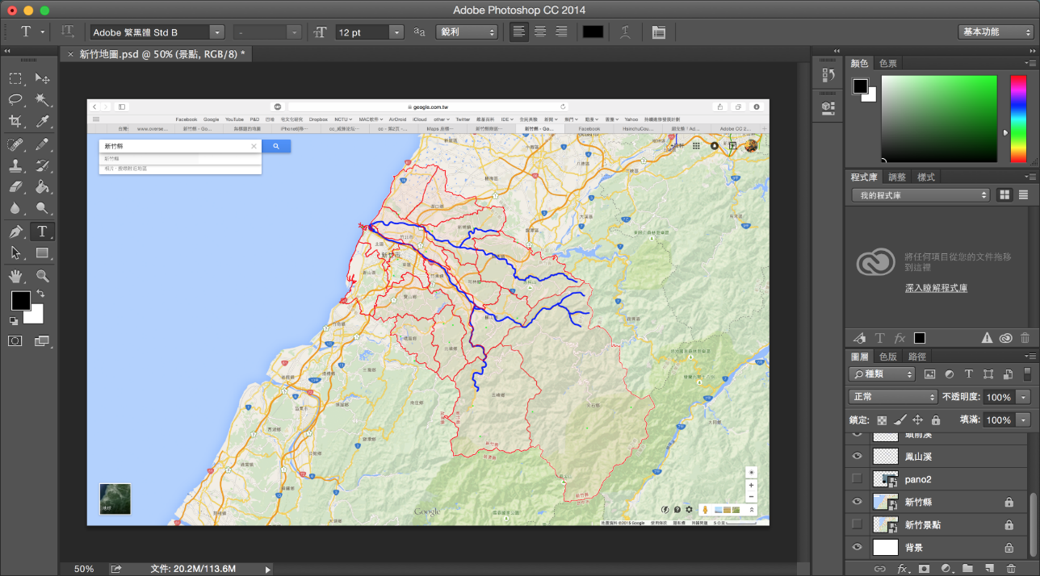

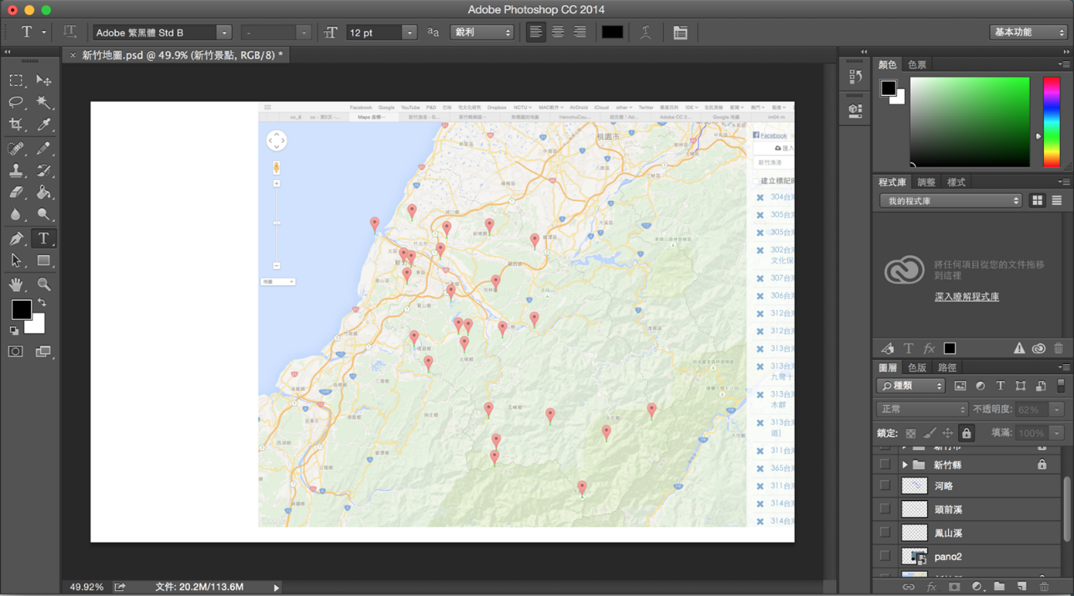

**The Second Step**

**After the initial stage, we are trying to use a C++program to simply the thick line to the thin one in order not to read every pixels by ourselves. The reason is that the process on the former stage does not meet our expectation. What we want is a “thin line” so we should modify the PSD file further. Though the program, we transform several squares (dot) to just one square (dot), and connect every square (dot). Then we can approximately make them into thin lines. Actually, how does this program work?**

**We read BMP files with the program. From south to north, we record every individual country boundaries and assign a number tag to each of them and then erase the unnecessary squares (dots) of boundary. What is next? We despair to use the program to automatically simply the overlap parts of three side by side countries. Therefore, we slightly modify it by hand. Finally, we can get the useful country boundary map (picture-4).**

**We use a different program to decide the scope of every country boundary from the number tag of country we can decide the coordinate of every country in sequence. In this process, we sketch again to decide and check if every area of country has problem, and finally get the precise map.**

**Subsequently, we use another function to draw the river. We use it to sketch the river from left to right in the map. Because the curve of the river is very complicated, we use a different algorithm, than the cities boundaries’ algorithm, to sketch the river (picture-4).**

**The tourists attractions is much easier, we just directly dot the points on the map (picture-5).**

**The team binary has export the coordinates to the TXT file. Therefore, team database and team GUI can use it .**

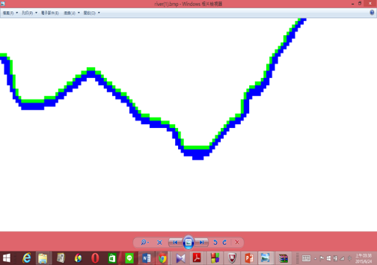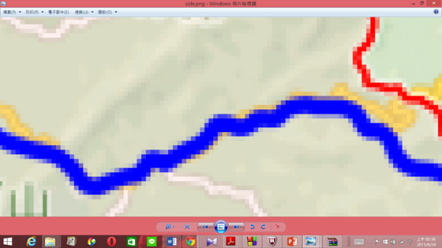

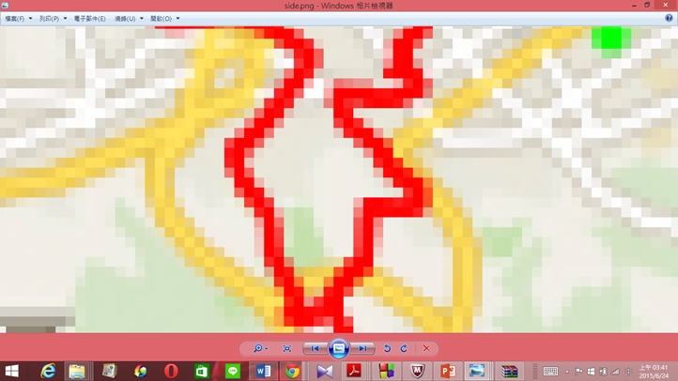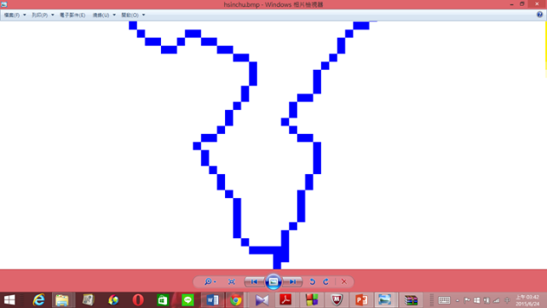



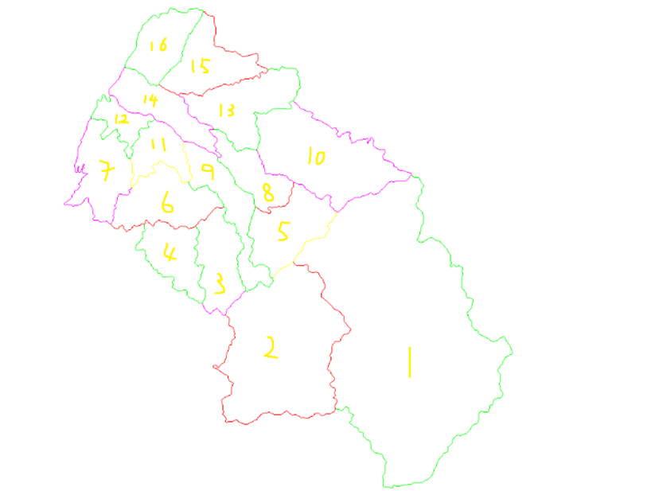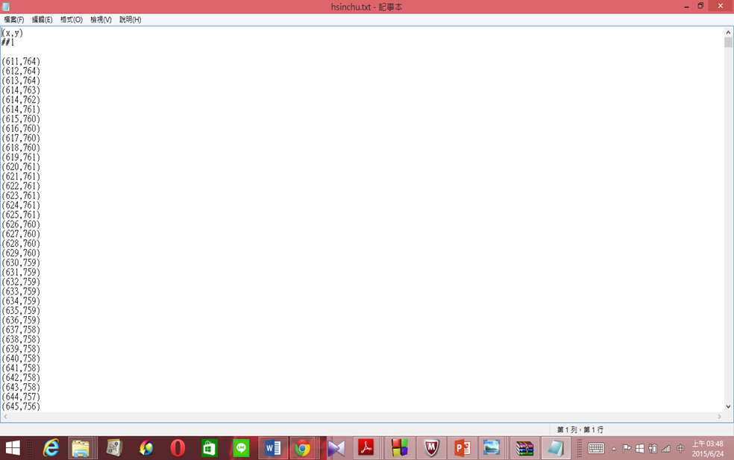

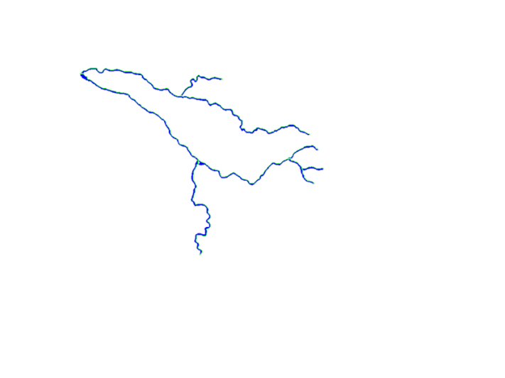

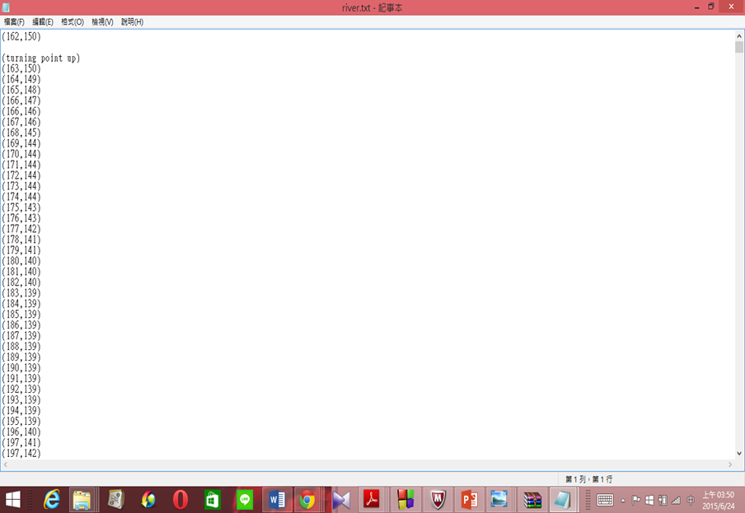

**Difficulties:**

1. **Had better use Photoshop proficiently**
2. **The original map is complex, we must carefully and thoroughly understand the map and use program to simplify it, sometime should manually complete it.**

**Team Database**

**After the team binary we got everything we need to put onto the SQL server. The picture and coordinate data to Team data base and Team GUI. To be more convenient to create database and draw the final complete map. Team Binary add some mark on the map (picture).**

**There is a member in Team Database, and his mission is create the table according to condition which TA gives.**

**Team Database gets the data and coordinates from Team Binary, and then get the remark and ID, and we can complete the Database and give it to Team Query and Team GUI.**

**The table of database has city id, river id, coordinates dots, population…..**

**Difficulties:**

**Need to communicate with Team Query and Team GUI clearly and do best to meet their requirement.**

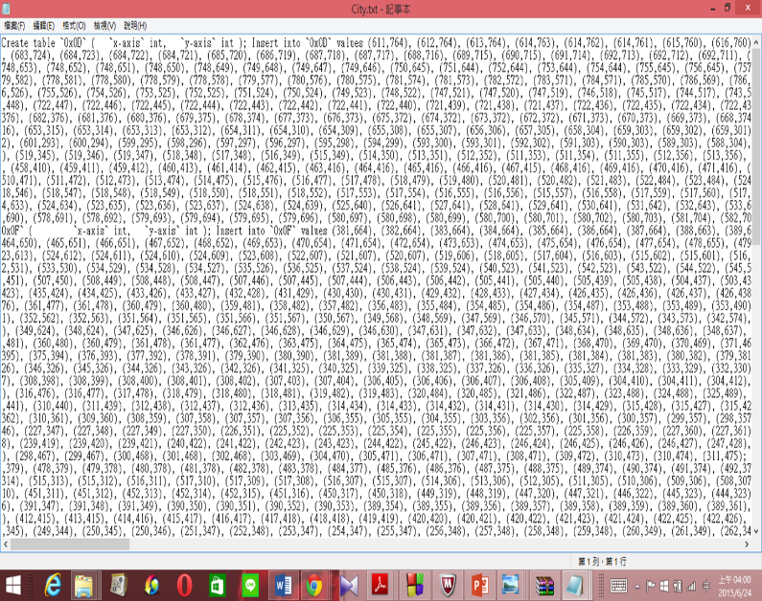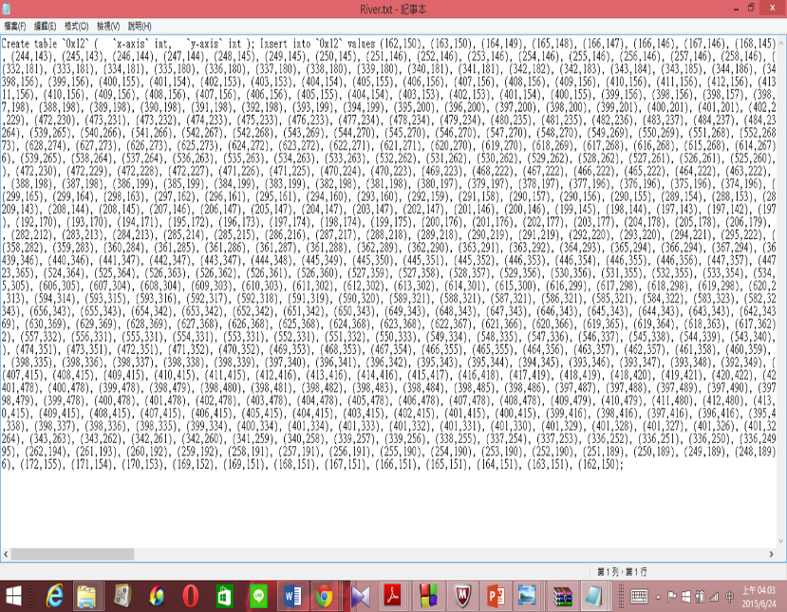

**Team Query**

**There are four members in Team Query, the main purpose is connecting with Team database and Team GUI, and the tool which Team Query use is C program. When we make command in GUI,**

**Team Query should program to pass this command to Database, and Database return data which we want..**

**When Database return the data, Team Binary should transform it to the form what Team GUI can use to show the result.**

**The missions of Team Query are following: First, arrange the data of database, then store coordinates in the structure and there are pointers point to the structure. Second, according to different sequel command, Team Query should use pointer. Point to the city id or river id, and use “malloc” to create space to store data.**

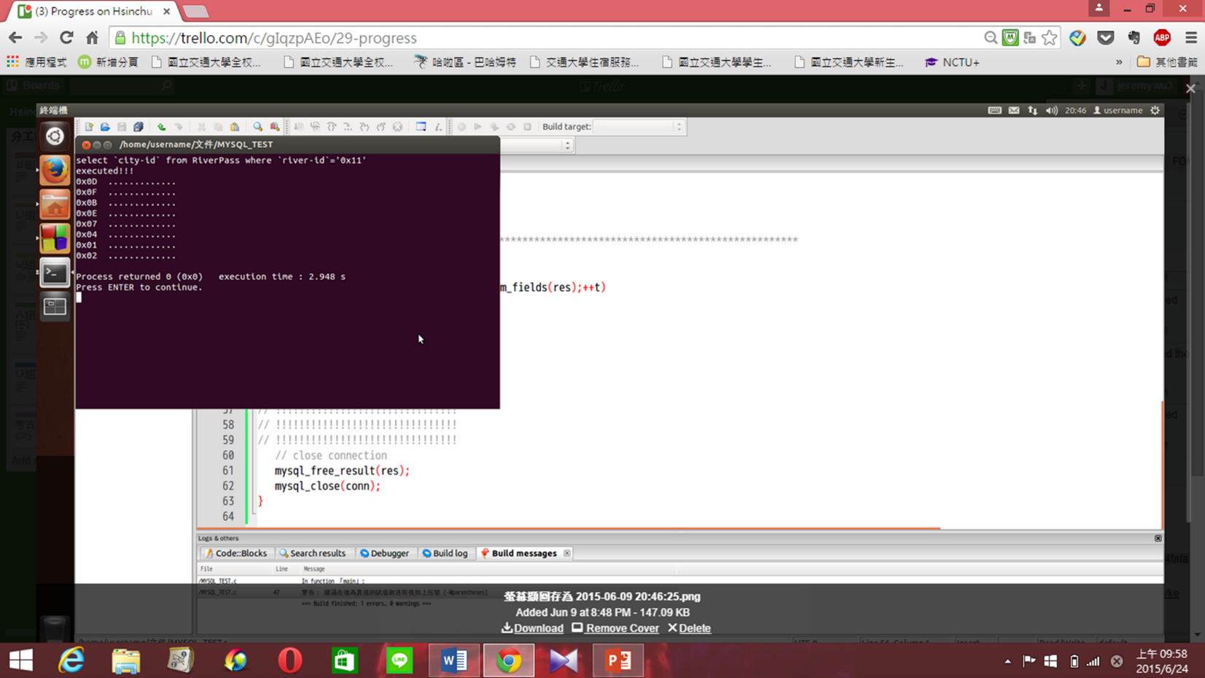

**Team GUI**

**The mission of Team GUI is create the API, read the sequel command, and gragh the map in different type of map.**

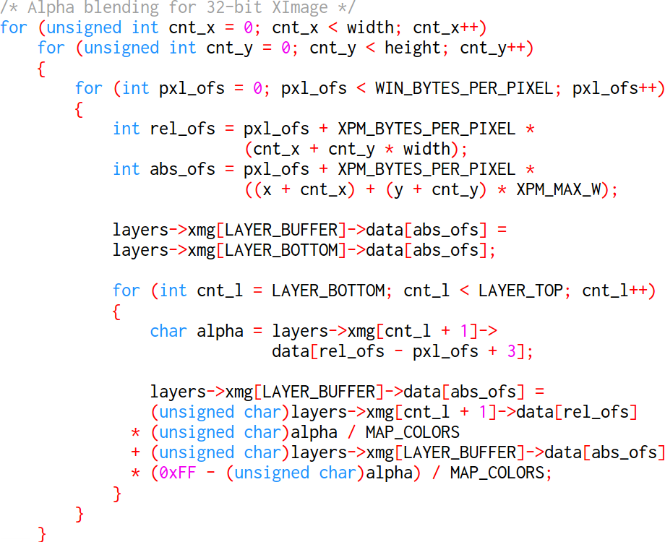

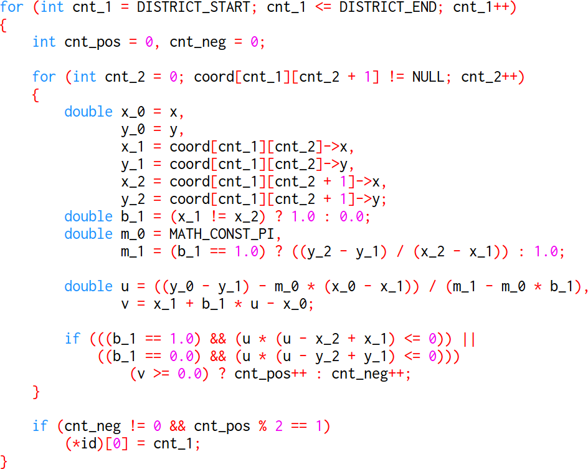

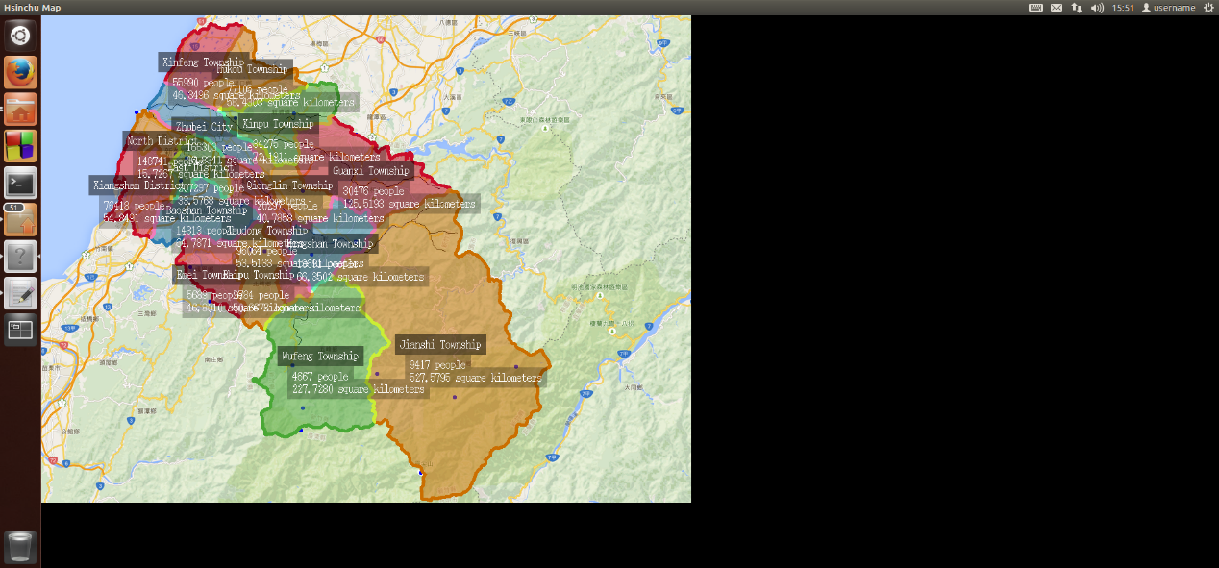

實際DEMO情況

